APPLICATION FORM
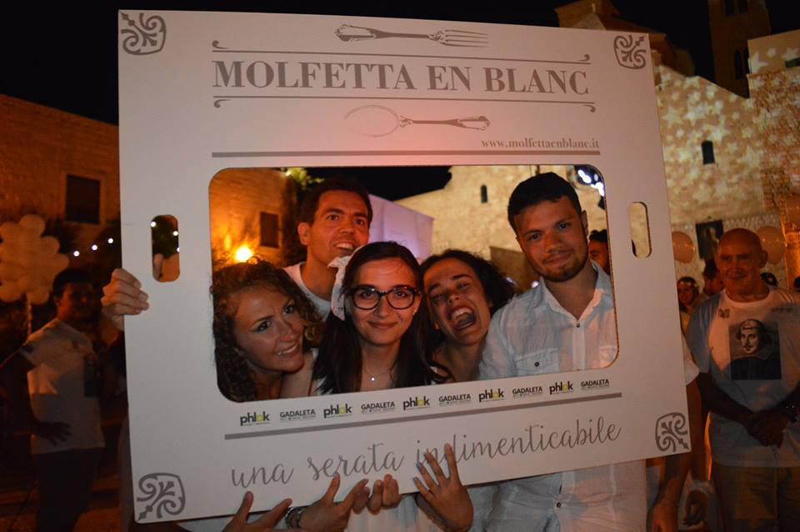for in the field of Youth

Thank you for your interest in our project. We would like to understand better your motivation in taking part in this specific project. So please, read carefully the form, answer the questions (in English or Italian) and do not forget to ask your sending organization to send the form together with your CV with picture.
Ti ringraziamo per l’interesse che hai per i nostri progetti. Vogliamo capire meglio la tua motivazione a prendere parte a questo specifico progetto. Quindi, per favore, leggi attentamente il formulario, rispondi alle domande (in italiano o in inglese) e non dimenticarti di chiedere alla tua organizzazione di invio di inviare il formulario assieme al tuo CV con foto.

1. YOUR MOTIVATION. LA TUA MOTIVAZIONE.
1.1 Where would you like to do your voluntary service (if you want to apply for more than one organization please use another application form)? Dove vuoi svolgere il tuo servizio di volontariato (se vuoi candidarti per più di un'organizzazione, devi compilare un altro modulo)?
1) Associazione InCo - Molfetta
2) Cooperativa CLAD

1.2. Description of the project. Descrizione del progetto.
Please, describe, using your own words, how you imagine a typical day will be like in your receiving organization. Per favore, descrivi a parole tue, come immagini una giornata tipo presso il tuo ente di accoglienza.

1.3.Your motivation La tua motivazione
Please describe below carefully your motivation for this specific project. Per favore, descrivi accuratamente di seguito la tua motivazione per questo progetto specifico.

1.4. Knowledge and skills you can share during your EVS experience. Conoscenze e competenze che potresti condividere durante la tua esperienza di SVE.

1.5. Knowledge and skills you hope to gain during your EVS experience. Conoscenze e competenze che speri di ottenere durante la tua esperienza di SVE.

1.6. Which challenges do you think you will encounter during your stay abroad? Quali sfide pensi di dover affrontare durante la tua permanenza all'estero?

1.7. Please indicate at least 3 of your strengths and do not forget to illustrate them giving an example. Per favore, indica almeno 3 dei tuoi punti di forza e non dimenticare di illustrarli attraverso esempi.

1.8. Please indicate at least 3 of your weaknesses and do not forget to illustrate them giving an example. Per favore, indica almeno 3 dei tuoi punti di debolezza e non dimenticarti di illustrarli attraverso esempi.

1.9. Please, indicate some activities you do not like to do. Per favore, indica delle attività che non ti piace fare.

1.10. Is there anything else you would like to tell? C'è qualcos'altro che vorresti aggiungere?

2. PLEASE FILL IN THE FOLLOWING DETAILS FOR YOUR APPLICATION!

PER FAVORE INSERISCI I SEGUENTI DATI PER LA TUA CANDIDATURA!

2.1. Personal information. Informazioni personali.

Name  Nome |  | Surname  Cognome

Gender  Genere |  | Nationality  Cittadinanza
Date of birth  Data di nascita |  | Place of birth  Luogo di nascita
Passport (ID) Number
Numero di passaporto
Person to contact in case of emergency (Name, Address, Telephone and Email). Persona da contattare in caso di emergenza (nome, indirizzo, telefono, email).

2.2. Special needs. Bisogni specifici.
Do you have any special needs (medical conditions, handicaps, etc.)? Hai bisogni specifici (condizioni mediche, handicap, etc.)? | Yes __ | No __
Do you have any kind of allergy? Hai qualche allergia? | Yes __ | No __
Do you need to take any kind of medicine? Devi prendere qualche medicina? | Yes __ | No __
Is there any food you do not eat? C'è del cibo che non mangi? | Yes __ | No __

2.3. Please give further description if you have answered “YES” to any of the above questions. Per favore, daI una descrizione più dettagliata per i campi dove hai segnato “YES”.

Declaration
I declare that all of the information on this application form is honest and truthful to ability, experience and support needs and has been completed by the volunteer named on this application.

Please tick here to show you understand and accept the above declaration
Do not forget to send together with this form your CV with picture!

Thank you for filling in the application form! The next page is for your sending organisation.
Grazie per aver compilato il formulario di candidatura! La pagina successiva è per la tua organizzazione di invio.
Please note that we can only accept your application if you indicate your sending organization and attach your CV with picture!
Per favore, nota che accetteremo la candidatura solo se indichi l'organizzazione di invio e alleghi il tuo CV con foto!

3. FOR YOUR SENDING ORGANIZATION

PARTNER IDENTIFICATION FORM
PARTNER PROFILE
PIC
Promoter’s legal name (national language)
Promoter’s legal name (latin characters)
Acronym, if applicable
National ID number, if applicable
Department if applicable
EVS Accreditation Number -EI Ref
Legal address
Postal code
City
Country
Region
Web site
Email
Telephone
Person authorised to legally commit the promoter (legal respresentative)
Title
Family name
First name
Position
Email
Telephone 1
Telephone 2
Same address as the organisation (if address is the same as the one of the organisation please tick this box, otherwise please use the box below to input the full address
Same Address

Person responsible for the implementation of the action (contact person)
Title
Family name
First name
Position
Email
Telephone 1
Telephone 2
Same address as the organisation (if address is the same as the one of the organisation please tick this box, otherwise please use the box below to input the full address

TYPE OF ORGANISATION (please respond YES or NO to the following questions)
Is your organisation a public body?
Is your organisation a private entity?
Is your organisation a non-profit?:
Is your organisation: a public body at regional/national level; an association of regions; a European Grouping of Territorial Cooperation; or a profit-making body active in Corporate Social Responsibility?-

ACCREDITATION (Has the organization received any type of accreditation before submitting this application?)
Accreditation Reference (EVS)
Any other type of accreditation relevant to the application for this project

BACKGROUND AND EXPERIENCE
Please briefly present your organization
What are the activities and experience of your organisation in the areas relevant for this application?

What are the skills and expertise of key staff/persons involved in this application?

About your volunteer (if already identified)
> Brief description of your volunteer

> Participants with Fewer Opportunities? Please specify
Budget
> Using the distance calculator of EU, please inform us the total Km and budget requested for travel (http://ec.europa.eu/programmes/erasmus-plus/tools/distance_en.htm):
….......... Km ….......... €

> Budget requested for visa/vaccination costs (if applicable):

